Digits and words  17  seventeen | 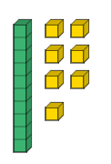  Draw it | 10s and 1s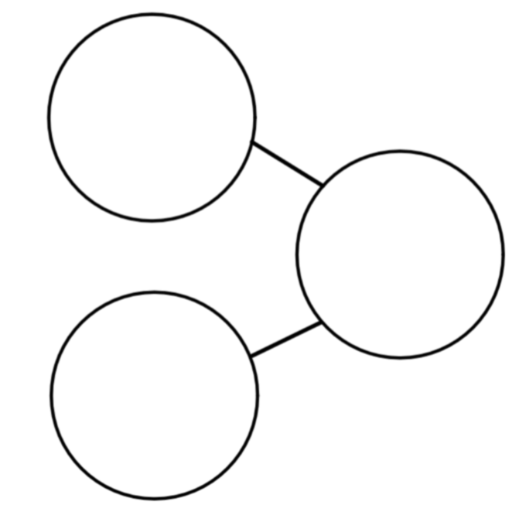  7  10  17 | MIX IT UP!  17  2  15 | MIX IT UP AGAIN!  17  5  12 | Addition number sentences  10 + 7 = 17  7 + 10 = 17
Digits and words  43  _________  ___________ | Draw it | 10s and 1s | MIX IT UP! | MIX IT UP AGAIN! | Addition number sentences  _____ + _____ = _____  _____ + _____ = _____
Digits and words  85  _________  ___________ | Draw it | 10s and 1s | MIX IT UP! | MIX IT UP AGAIN! | Addition number sentences  _____ + _____ = _____  _____ + _____ = _____
Digits and words  62  _________  ___________ | Dienes | 10s and 1s | MIX IT UP! | MIX IT UP AGAIN! | Addition number sentences  _____ + _____ = _____  _____ + _____ = _____
Name______________ Year 2 Maths homework. Handed out 18.9.23. Due 25.9.23




